**SECTION – 3**

**GIT BRANCHING**

**JAVASCRIPT ASSIGNEMENT**

**Objective: Commit HTML, CSS & JavaScript assignments into GIT.**

**SECTION-3 - (JavaScript assignments) Steps to follow: (PART-1)**

1. Create a new branch 'js-assignments.

2. Switch to 'js-assignments' branch.

3. Copy all JavaScript assignments inside 'Assignments' folder.

4. Commit JavaScript assignments into 'js-assignments' branch.

5. Make minor changes into README.txt file on line 1 belonging to js-assignments branch.

6. Commit those changed files.

7. Switch to master branch.

8. Make minor changes into README.txt file on line 1 & commit those changes into master.

9. Again switch to 'js-assignments' branch.

10. Make minor changes into few files belonging to 'js-assignments branch.

11. Commit those changes.

12. Switch to master.

13. Merge 'js-assignments' branch into master. Confirm all JavaScript assignments are shown in master.

14. Finally delete the 'js-assignments' branch.

**QUERY TILL STEPS: 1-13 (**Before Deleting js-assignments Branch)

Till Merging of js-assignments branch to master branch:

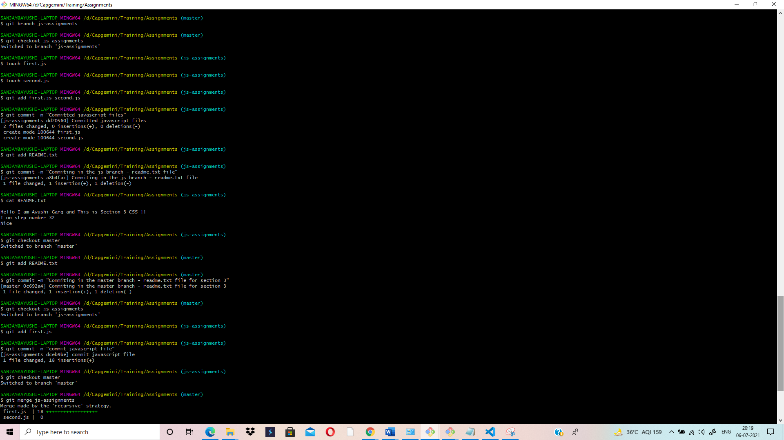

**QUERY TILL STEPS: 5-14**

After Deleting js-assignments branch-(Last Step)

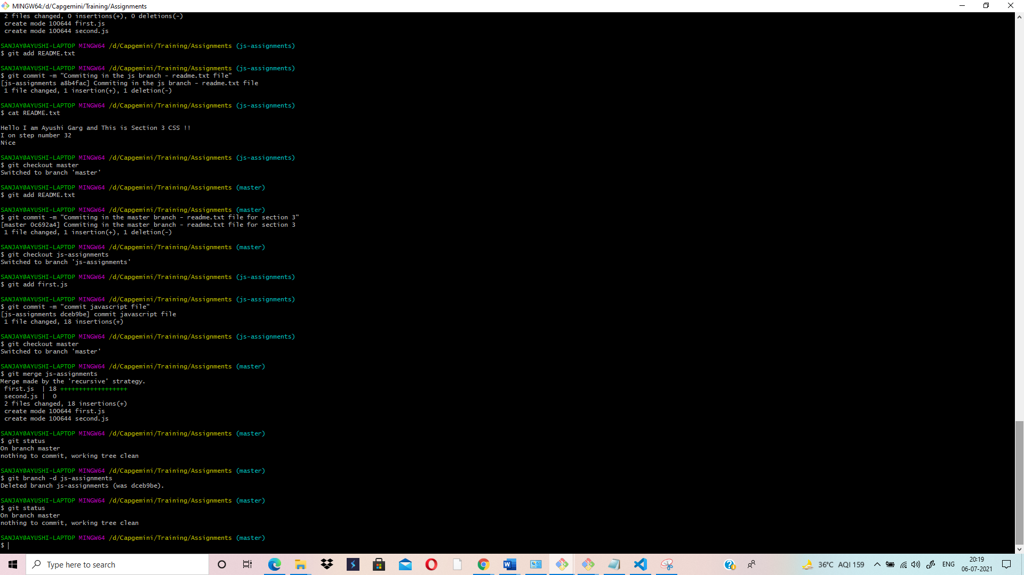

**TEXT EDITOR SCREENSHOT WHILE MAKING CHANGES IN README.TXT FILE:**

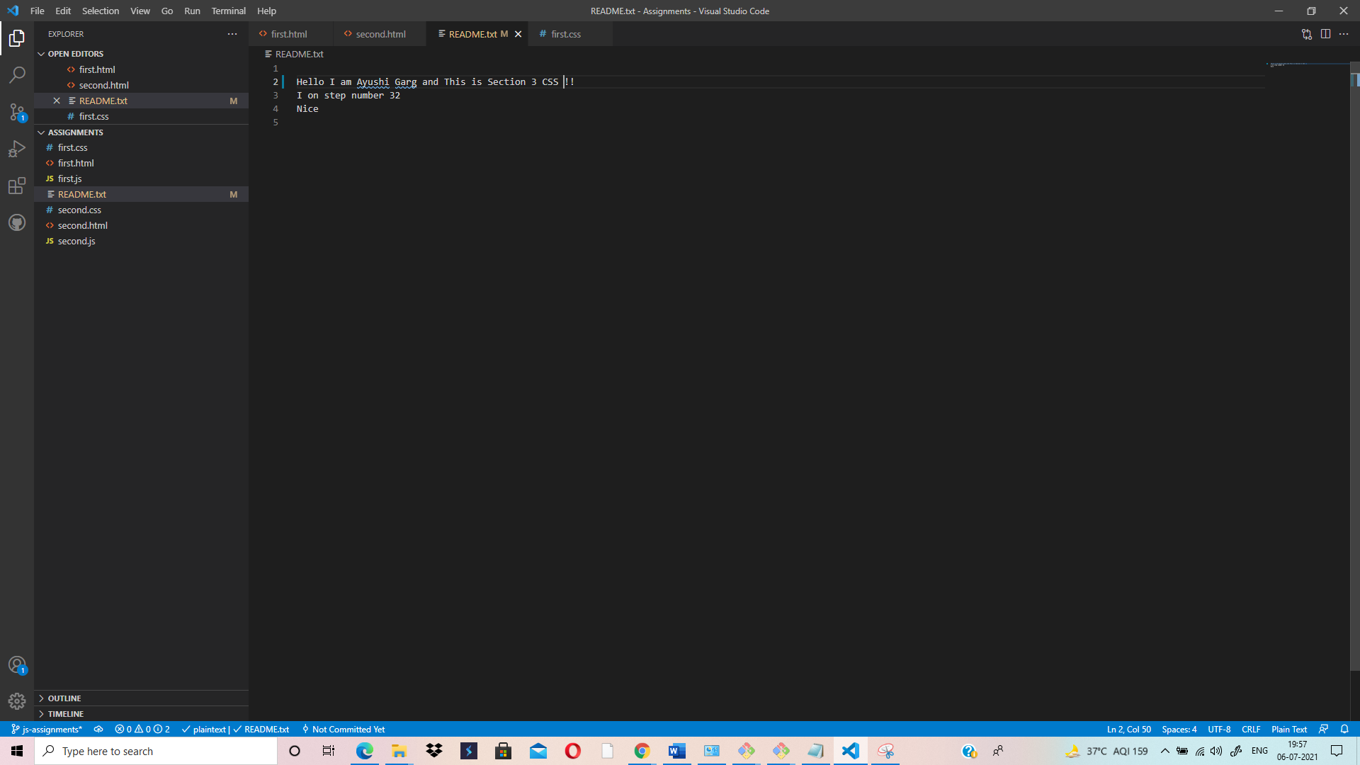

**VI-EDITOR APPEARS AFTER PERFORMING MERGING: SHOWS RECURSIVE STRATEGY WHILE MERGING:**

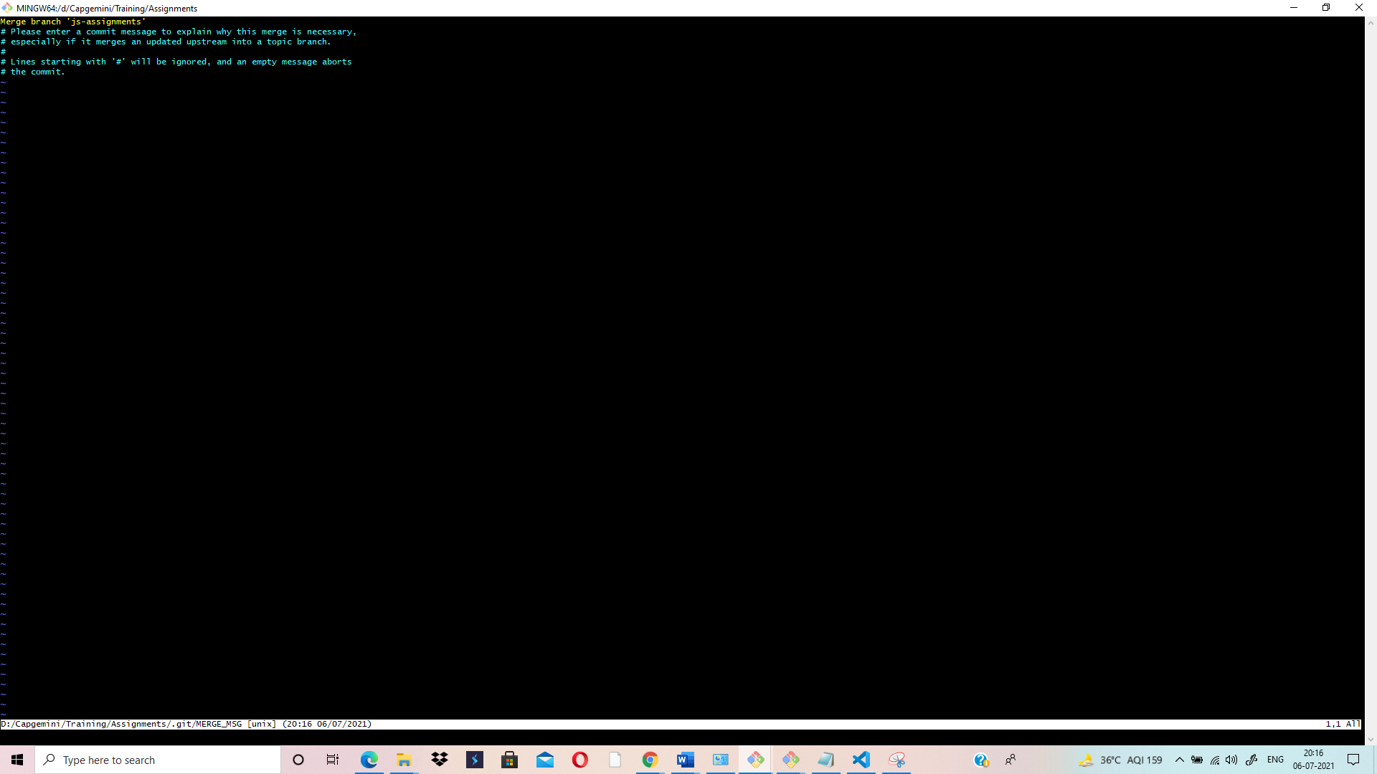

**SECTION – 3**

**GIT REMOTING**

**Objective: Pushing source code into GITHUB & collaborate team members.**

**SECTION-3 (Pushing assignments to remote repository)- Steps to follow: (PART-2)**

39. Create a github account if you do not have already.

40. Login on into github account.

41. Create new public repository 'freshersbatch-oct16'.

42. Commit & push any sample file to this repository under 'Assignments’ directory.

**QUERY TILL STEPS: 5-14 AND ALSO FROM STEPS: 39 TO 42**

Till Deleting js-assignments branch and Committing & pushing any sample file to the github repository under 'Assignments’ directory- (Last Step)

Connecting the local repository to Github Repository:

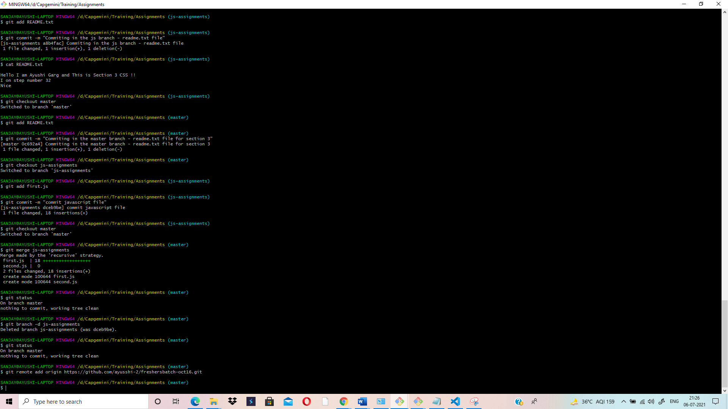

**STEP:42 (Pushing the Assignment Folder to Github Repository in Git CMD)**

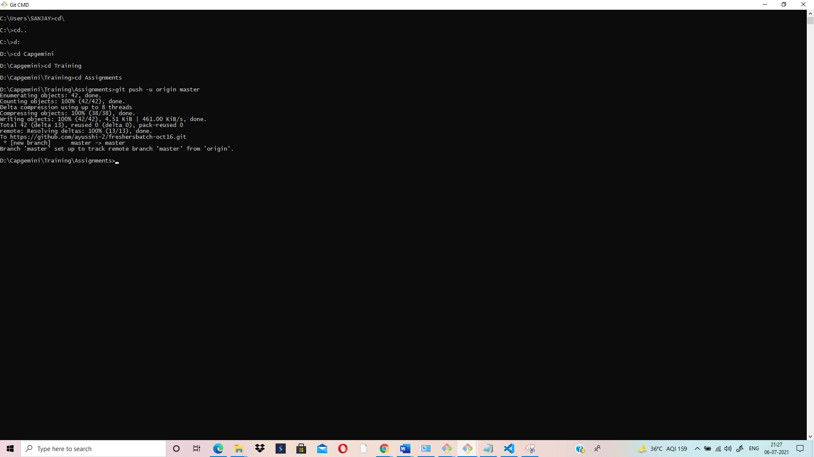

**GITHUB REPOSITORY AFTER PUSH OPERATION:**

